Is your animal in pain? Body language is everything!

Unlike ourselves, unfortunately an animal cannot tell us if and where they are in pain! It is because of this that there are many systems out there regarding how to detect whether an animal is in pain.

The most common is a PAIN SCORING system, which can gauge the level of pain and discomfort an animal is feeling based on physiological and behavioural changes. These can have variable scales, e.g from 1-10 or 1-5, but all feature similar aspects to the tables here:

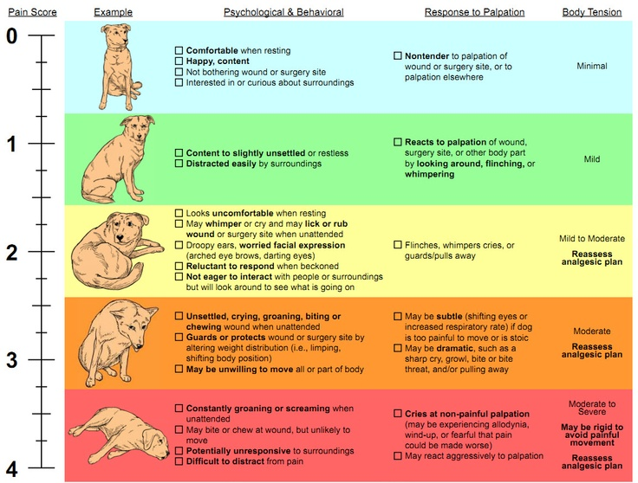

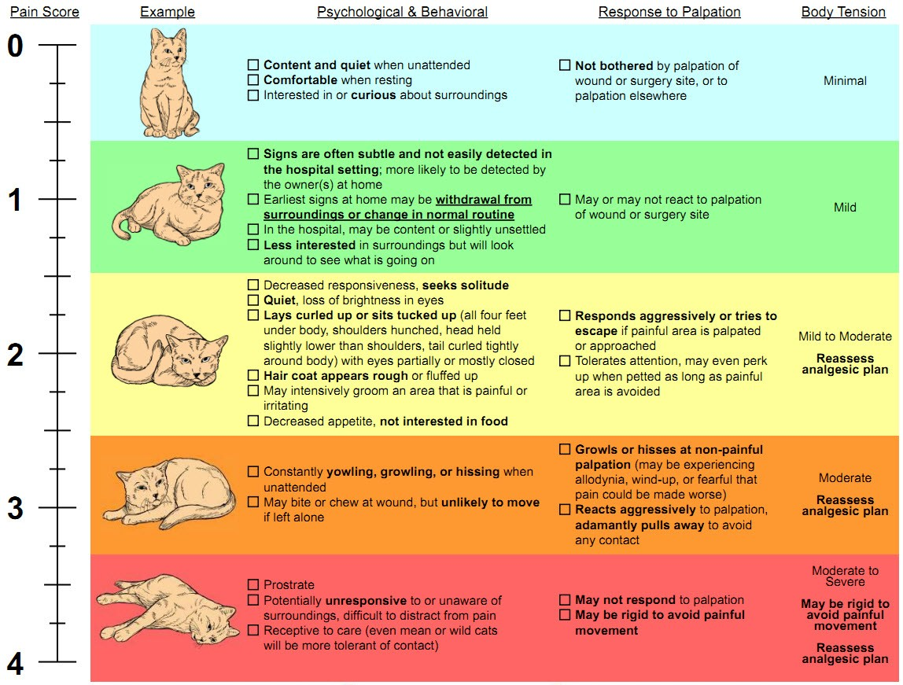

If your animal is in the 2-4 range, seek veterinary attention IMMEDIATELY. The scales relate to wounds and post operative pain, but ANY pain should warrant veterinary attention.

Even if your animal is in the 1 category, seek veterinary attention in the next 24-48 hours as subtle signs may not always equate to subtle problems!

We hope this will help use ‘serve those you love’ EVEN BETTER!

Categories: [MEDIA RELEASE](http://oceanreefvet.com.au/category/media-release/)